Data Analysis Assignment

Part 2: Processing the data -

Python files found at:
https://github.com/841ellis113/Skills-Bootcamp-Assignment---Bike-sales

When generating the data, it is to be looked at and considered. It must be noted that although included within this section as a ‘log’ of what was done, that does not mean that a particular set of data or graph would be used within the final product given to the customer.

Overview of the business -

The first general task will be to load the data and tables to SQL and then briefly look through the data to get a feel for what is contained within. We can use SQL to sum up the sales and product tables to get the total number of sales and items sold, to be used later. There are 300 individual sales and there are 504 items sold. We can also use min/max functions to work out the range of dates the sale occurred, using SELECT min(SaleDate)/Max(SaleDate) FROM tblSales. As such the dates range from Jan 1st 2022 until Dec 30th 2022.

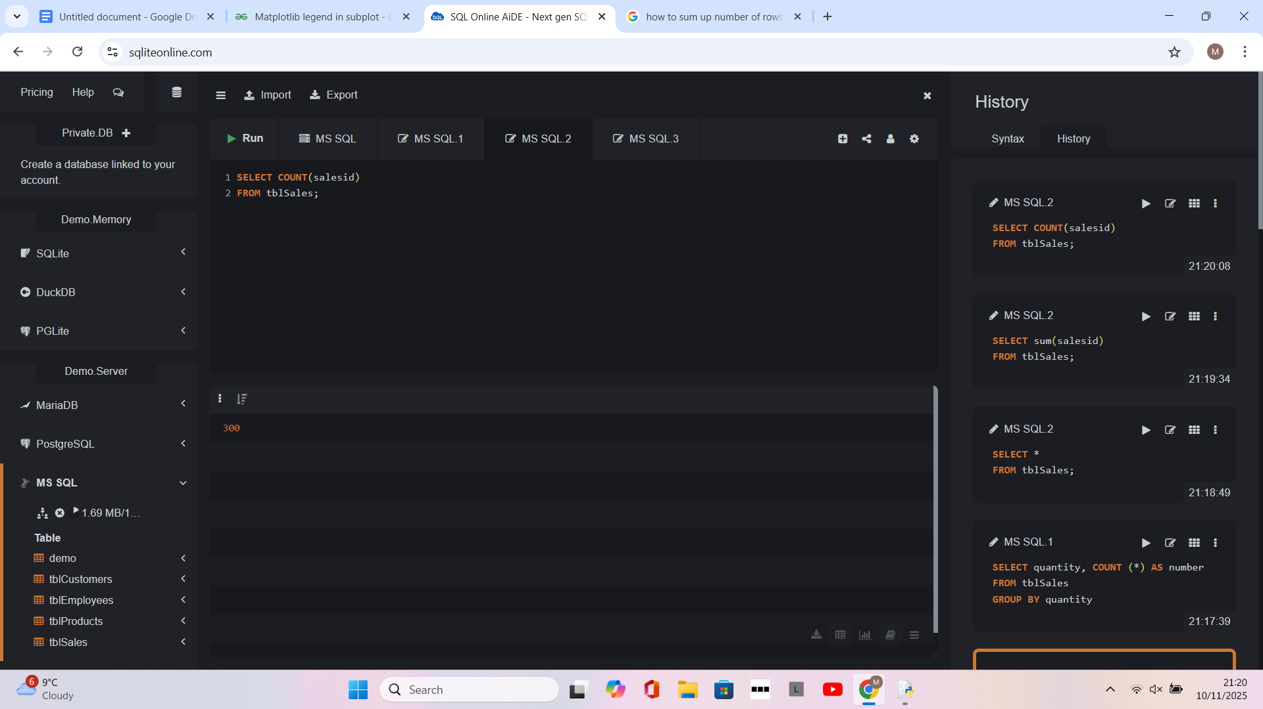
Using SELECT command to call all within the sales table and using count() to get total number of rows or sales

Next we will join the sales and products tables and return the ‘salesdate’, ‘quantity’, ‘price’ and ‘name’ using the productID in both tables as the location of the join and export to python so that we can begin to manipulate the data such as determining the value of sale (quantity * price) and start grouping the data by date.

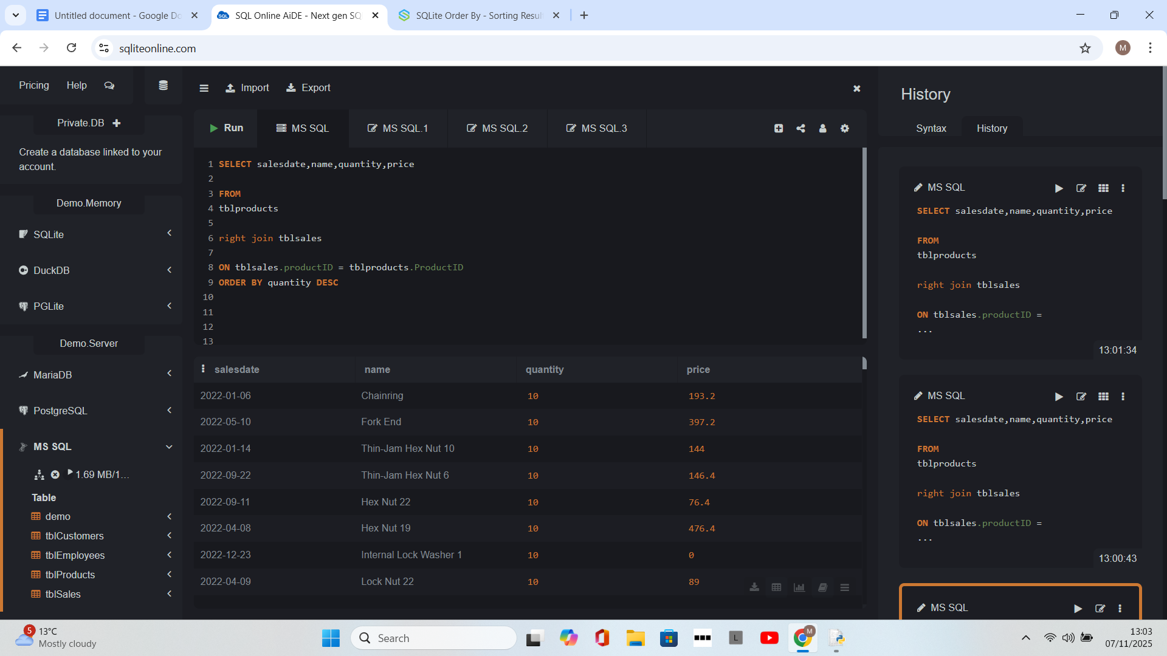
Using the join command to join two tables and exporting.

There appears to be 28 transactions that have no value or 0 value. And within these 28 transactions, there are a total of 162 items sold for 0 price.
The reason for this could be numerous; missing data, mistakes on data entry or possibly free giveaways or promotions that need to be itemized for stock. To that end, we would advise the customer and let them decide what to do. This also means that, the above data needs to be adjusted for the 28 zero transactions (162 items)

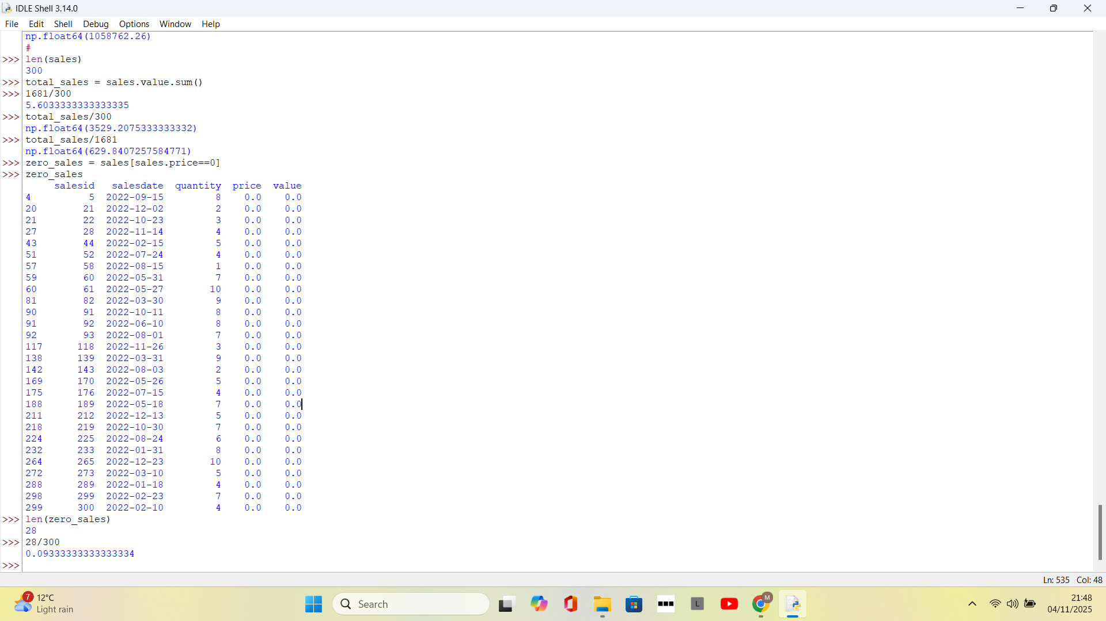
Transactions that have zero value and are to be removed

Going forward, these zero transactions will be removed prior to analysing any data. To get stats relating to the data, we use the .describe() method within pandas. We also sum the value column to get the total revenue for the year.

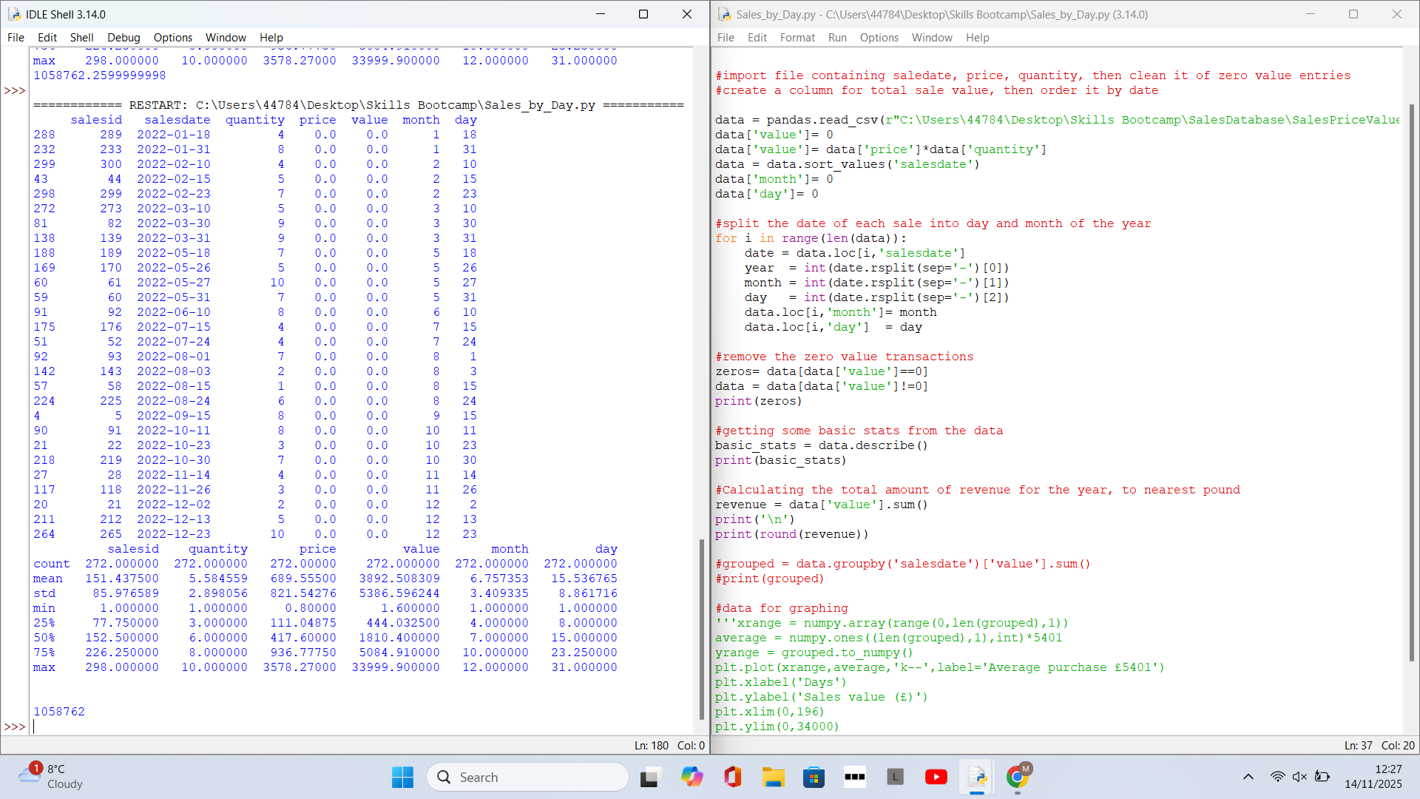
Using the .describe() method to gain statistical insight and total revenue and zero value entries.

Using the describe() function, we can determine stats for total revenue, the number of items sold, the most / least sold as well as the most and least valuable items in stock.
By ordering the data we can see the most valuable individual items in terms of the ones that generate the most revenue and also the items that sell the most units. The items that sell very little number are also grouped. We also look at the 28 zeros value transactions out of interest, noticing that the vast majority of items in this category are washer, bolts and nuts etc.

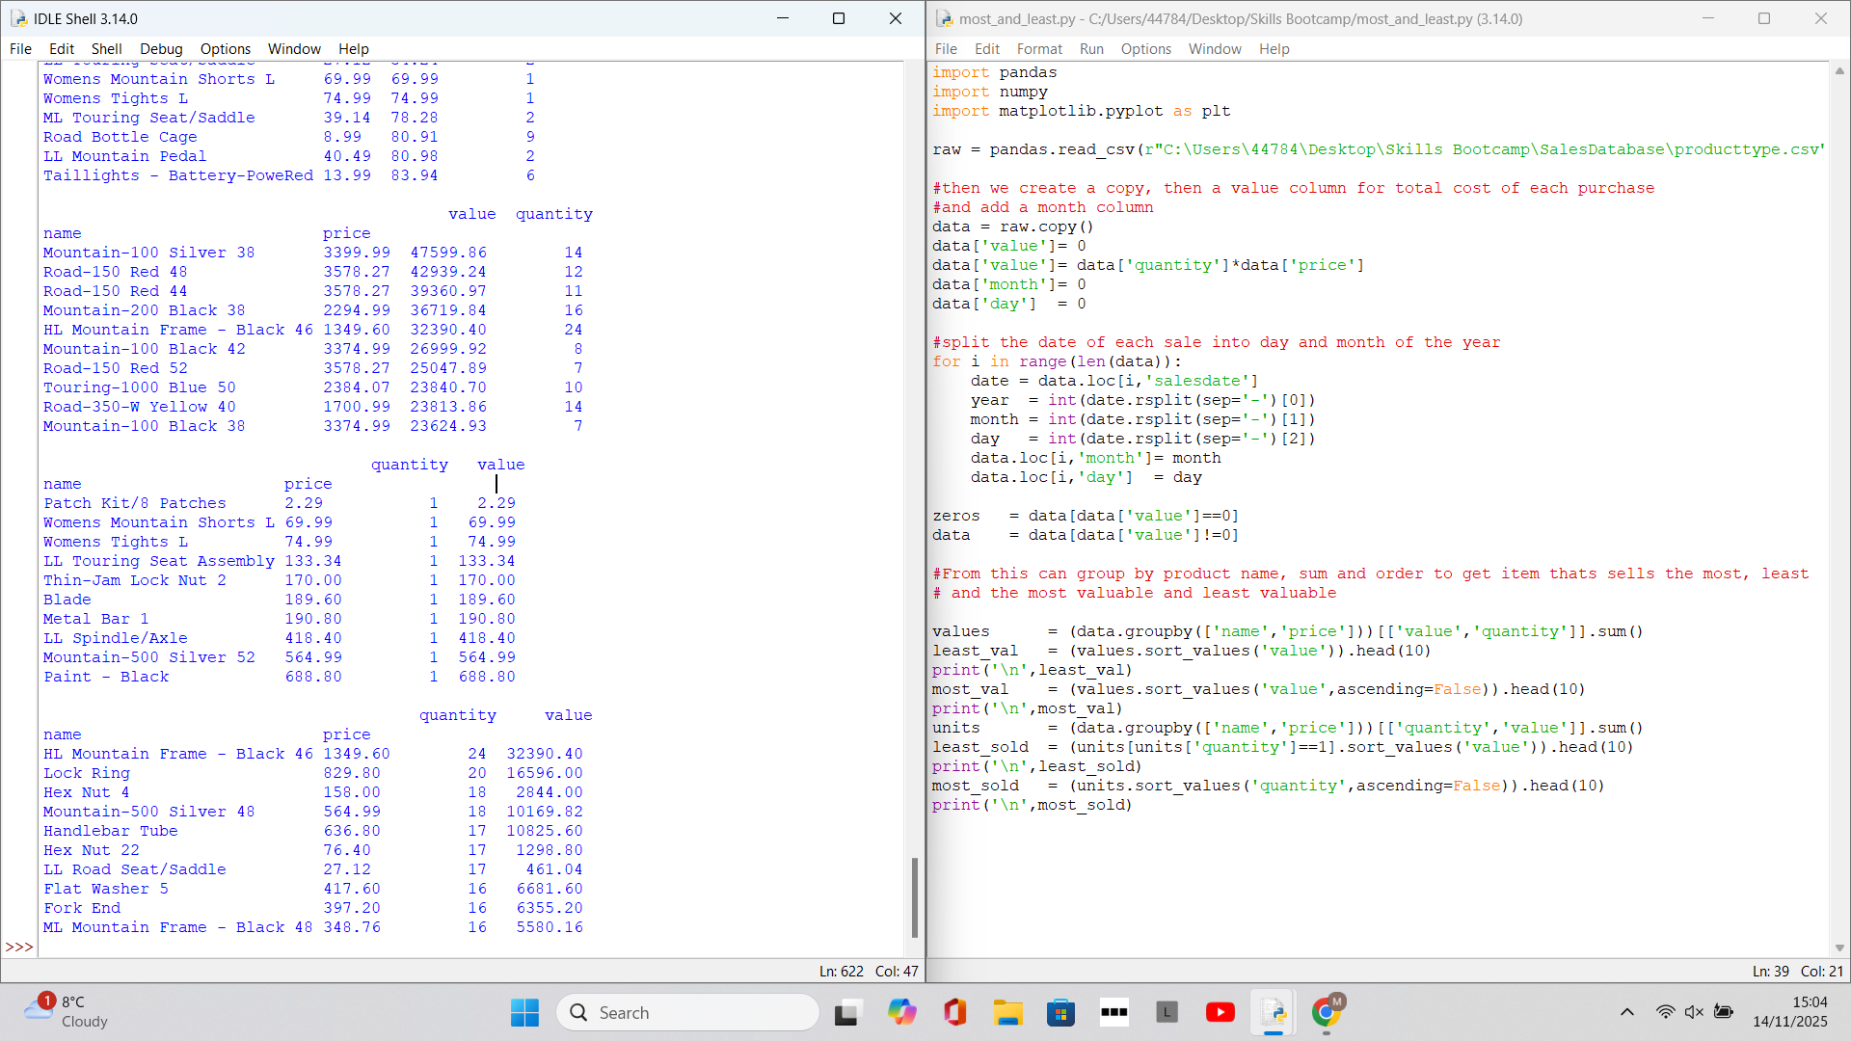
Generating data for highest/lowest revenue and units sold

Sales and units sold grouped by month -

We can work with the data to get values of the transactions to get some monthly data. In particular we can see how the total value of sales over the year per month is doing and also how many items are being sold per month. This could give insight into any generalized trends for example due to the seasons.
This could also indicate the busiest time of the year to aid in staff levels and even help with stock levels being prepared for sales based on previous history
To do this we first remove the zero value sales and then run a python script to label the month of sale for each transaction from the salesdate column. We then proceed to use the groupby() ability of Pandas to group by month and then sum by each of the ‘value’ column (sales value), quantity (number of items sold) and salesdate.

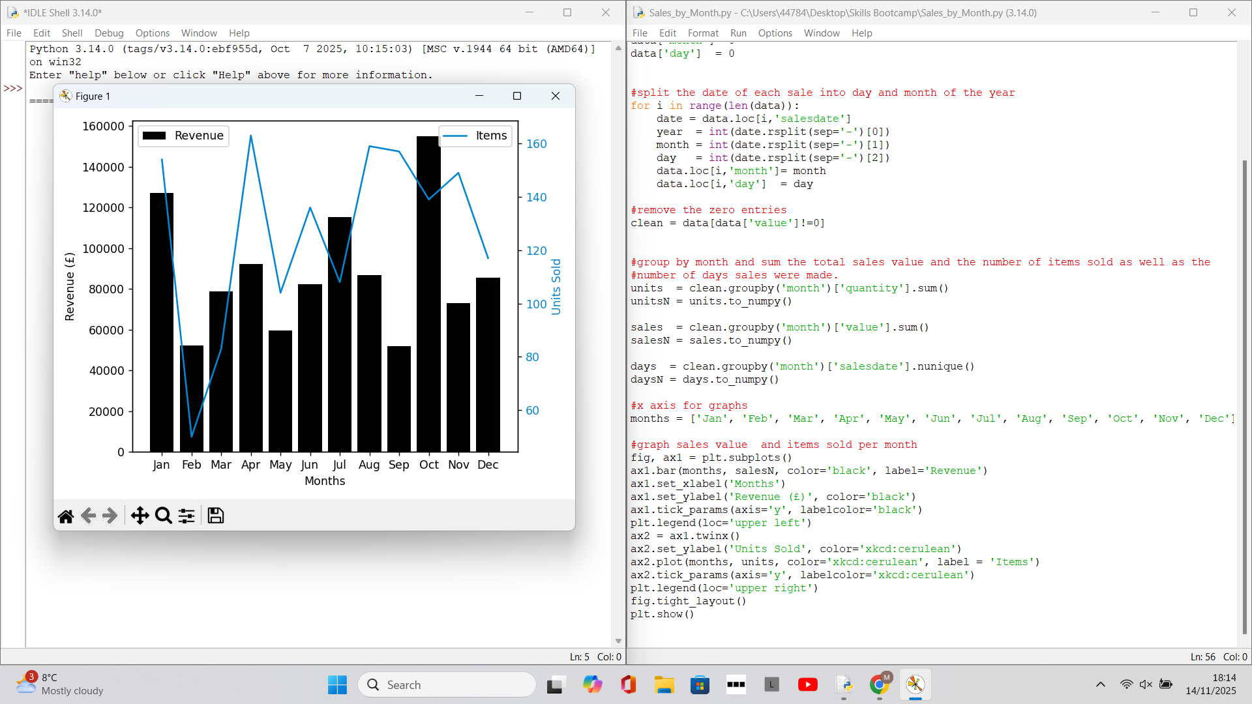
Python script to manipulate monthly data

Grouping Products by type (‘Bike’, ‘Parts’, ‘frames’ and ‘Clothing’) -

The data is grouped by ‘Bike’,’Parts’ (including frames) and ‘Clothing’ and the total revenue that each type generates, along with units sold, is graphed and analyzed. Again this is done by grouping the data by month and also grouping by category. The parts are labelled as either bike, part or clothing by scanning the description of the item and looking for key words. For bikes, this was the suffix of a number following a dash i.e. Road - 150 etc. For clothing it was one of 6 words that were items of clothing (such as shorts) and everything else was pre-filled with parts (as everything else was a part).
The data was first split into and summed for the 3 different types of categories and graphed as a bar chart so that they could be compared. Then after grouping by month, the data was produced as a stacked bar chart.
We then split parts further into frames and other parts with the key word within the description being ‘frame’. Doing so may help to understand the parts category in more detail. As before we produce a general overview and then breakdown by monthly units sales and revenue.

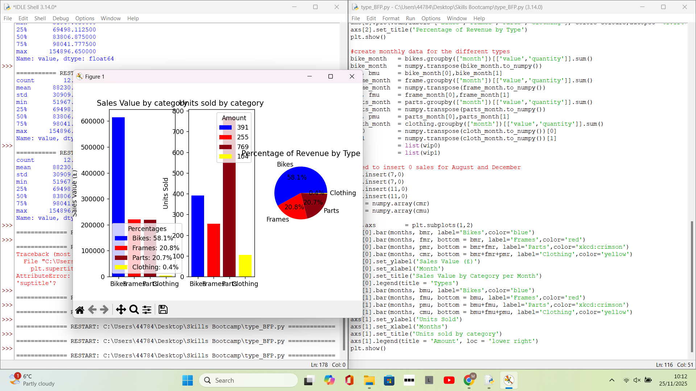
Breaking Parts into parts and frames and comparing with bikes and clothing

Grouping the bikes and frames in Mountain, Road and Touring -

After analysing the data for by item category, we decided to break the bikes category into the types of bikes that are sold. To the lay person a bike might just be a bike, but different bikes attract different customers and may have different seasonal patterns.

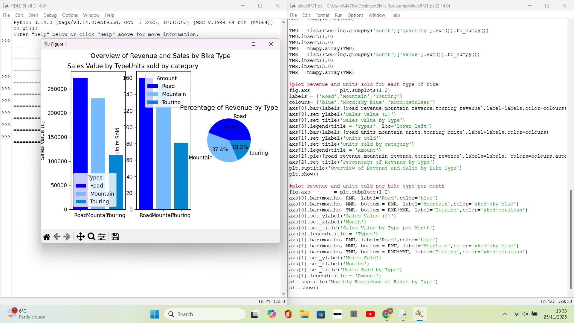
Breaking Bike sales into Road, Mountain and Touring types.

We look at the overall macroscopic trend for bike types then we analyse the monthly data as we have done previously. We then proceed to do the same for frames by type.

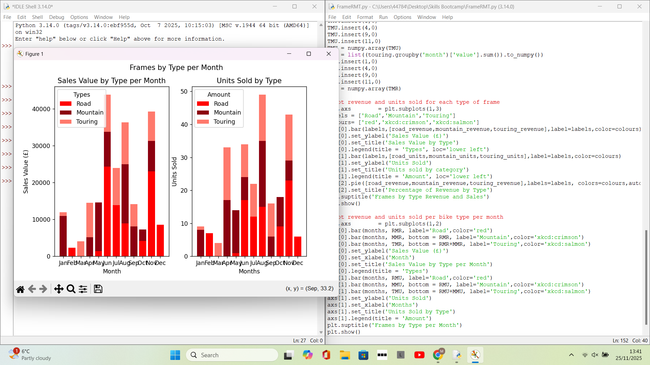
Monthly figures of frame type

Combining the frames and bikes could potentially give us information on what type of bike is the best seller and core product for the business.
In order to label each part, first a python dictionary is created with the labels ‘Road’,’Mountain’, ‘Touring’ and ‘Clothing’ being values. A word within the description that identifies the item as road, mountain or touring such as ‘Shorts’ is placed within the dictionary as a key. Different keys will have the same value (i.e. ‘shorts:’Clothing’ and ‘jersey’:’Clothing’ will have the same ‘Clothing’ value). We loop through each key and determine if within a description and assign whatever value is associated with that key to the category column in the dataframe:

for i in range(len(data)): #data is the name of the dataframe
description = data.loc[i,'name'] # description is variable name for column
for key in list(values2.keys()): #key is name for key in dictionary
if description.find(key)>0:
data.loc[i,'category'] = values2[key]
Break #once labelled, break to next loop value
else:
Continue #If not found, move to next. Do nothing.

Code used to loop over the dataframe to label each item.

Customer loyalty -

Looking at customer loyalty, we can look at stats such as the amount an average customer spends throughout the year and the number of customers that spend within given thresholds (e.g. above £20000). We can list the top spenders within the business and we can also separate customer expenditure into different categories as established before (Bike, Frames, Parts and Clothing) as well as some stats for the grouping.
First we use multiple joins within SQL to pull data from the customer and product onto the sales table using customerID and productID as the keys:

SELECT salesdate,name,quantity,price,firstname, middleinitial, lastname

FROM tblSales
LEFT JOIN TblCustomers ON tblcustomers.CustomerID = tblsales.CustomerID
LEFT JOIN Tblproducts ON tblproducts.ProductID = tblsales.ProductID;

After looking at the data, we see that only the middle initial column has null entries, so we fill these with blank spaces using pandas.fillna(). We remove the entries that have zero sales value and then to begin with, group the data by name and sum the revenue column to get the amount each customer has spent.

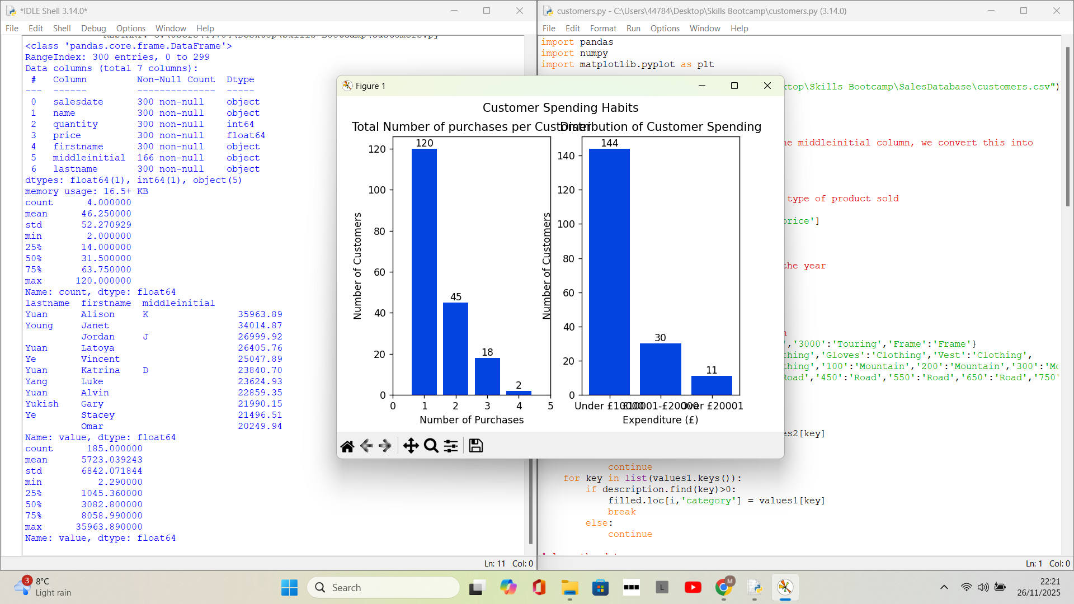
Analysing customer data.

